September 1934

TALES THAT SPARK PLUGS TELL
by Martin Bunn
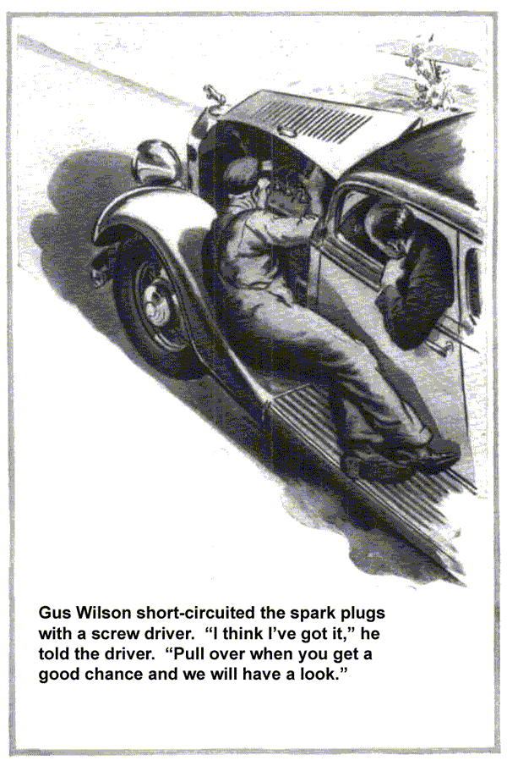
With Gus Wilson perched on a front fender, Tim Barret drove his car up the steep grade of Bluff Hill. As the car gained speed, the veteran mechanic crouched closer to the open hood and the driver poked his head out of the window, like an alert locomotive engineer.
"There it is. Hear it?" Barret shouted over the drone as the motor started skipping.
Gus nodded and reached, into his overalls pocket for a screw driver. Listening intently, he short-circuited each of the six spark plugs that studded the motor block. With the exception of the last plug, the miss grew more pronounced each time the contact was made.
"O. K. I think I've got it," the gray-haired garage-man shouted, jerking his thumb toward the spark plugs. "Pull over when you get a chance and we'll have a look."
"Funny thing about this car," Barret complained while Gus rummaged in his portable tool kit for a spark plug wrench. "She'll run fine for five or six days in a row. Then all of a sudden, she'll develop that miss every time she takes a hill. What gets me is that it disappears as quickly as it comes."
"Sort of takes a vacation now and then, suggested Gus with a grin. "Been acting that way long?"
"Not particularly," replied Barret. "Noticed it first about three weeks ago when I was down at the beach on my vacation. She acted that way for days at a time down there, but since I've been home, I haven't noticed it so much."
As Barret talked Gus touched the base of each spark plug, wetting his finger tip as a housewife does when testing a hot iron. Finally, he slipped the head of the socket wrench over the last plug in line and with a steady tug loosened its threads.
"How about dirt in the carburetor?" the owner suggested. "That'll make a motor miss, won't it?"
In his casual preoccupied way, Gus lifted the spark plug from its hole in the cylinder head and rubbed a knowing thumb across the tip of the insulator. Then after a careful inspection, he screwed it back.
"Unless I miss my guess, it's the ignition wiring," he said finally. "As long as I've got an extra set here in my tool kit, we might as well stick them in and see what happens. While we're here, we can try it out on this same hill."
A half hour later a second trip up Bluff Hill proved that Gus was right. The new ignition wiring completely eliminated the miss. In fact the whole car seemed peppier and more powerful.
"That sure turned the trick," agreed Barret as the two men started their trip back to the Model Garage. "But I still don't see how bum ignition wiring could make a car run the way this one did. Why didn't all the cylinders miss, and how come the trouble only showed up now and then?"
"Sort of a combination of circumstances," explained Gus. "In the first place, only one piece of that ignition wiring was bad. For some reason or other, it was resting smack on the motor and the heat just naturally rotted the insulation.
"When it was dry, it held up, but when there was a lot of moisture in the air, the water saturated the spongy spots and made a short circuit to the motor head. Naturally, the juice was shunted away from the spark gap and the motor missed.
"Down at the beach it was probably damp, especially at night when the fog rolled in, so the short circuit was there most of the time. When you came back here where it's drier, she only acted up when it was muggy and rainy. Chances are that heavy rain yesterday is what made it miss today."
"What gave you the hunch it was the wiring?" put in Barret, interested.
"The usual symptoms," replied Gus.
"Symptoms?" repeated the man. "Why, all you did was look at one of the spark plugs. What sort of symptoms can you see by looking at those greasy things?"
"You wouldn't think a doctor could tell much by feeling a patient's pulse or looking at his tongue, but he can," pointed out Gus. "When I found out which cylinder was missing my first hunch was a fouled spark plug. When I saw that it was fairly clean and just a bit wet, I decided that something else was keeping the juice from reaching the gap. The distributor was O. K., so my next guess was the wiring."
"Simple when you know how, isn't it?" said Barret, admiringly. "No wonder every one in the county knows Gus Wilson."
"Ever want to be a detective when you were a kid?" asked Gus, trying to ignore the compliment. "Well, finding out what ails a car isn't much different. First you've got to find the clues and spark plugs are good witnesses. They'll tell you about plenty of car troubles.
"I've never been able to see much difference in spark plugs," insisted Barret. "They all look alike."
"Not by a jug full," corrected Gus. "Every motor leaves its telltale marks on the plug that's been in use any length of time. Why shouldn't it, the spark plug ends being right down there in the business end of the motor." They come in contact with everything that makes the car run - air, gasoline, oil, and electricity.
"Lots of people wonder why the gap terminals on their spark plugs wear down so fast. Generally it's an indication that the carburetor mixture is too lean. If the tips of the insulators are straw colored at the same time, it's a cinch that a lean mixture is causing the trouble you are having in the engine.
"On the other hand, spark plugs in another car may show an accumulation of dry soot down near the points. Generally that means a mixture that's too rich. You can check it by holding your hand in front of the exhaust after the motor has been running awhile. If it smells strongly of gasoline, it bears out the spark plug symptom."
"I've always thought that a badly carbonized spark plug meant only one thing," said Barret, "and that's a worn piston and rings."
"Only when it's oily," said Gus. "If the plug is dry, the heavy crust of black carbon may be caused by any one of a number of different things. Bum timing, a broken connection, a low battery, poor breaker points, and leaky valves all can contribute to the carbon on a plug. If the rings are bad and oil is being pumped into the cylinder, the plugs are bound to be fairly wet and gummy.
"Generally, leaky pistons and rings will give themselves away by fouling the plugs almost as fast as you can clean them. If one or two cylinders particularly act that way it's a safe bet they're pumping oil."
"I had a funny thing happen to me about a year ago," interrupted Barret. "Took my plugs out one day to clean them and adjust the points and found that the tips on two of the insulators were cracked. What do you suppose caused that? The motor seemed to run fine when I put in new plugs."
Gus grinned, "Chances are you caused that trouble yourself. Good plugs seldom crack inside a motor unless it overheats. You probably made the mistake of bending the electrode that's embedded in the porcelain instead of the one that's joined to the metal shell. Naturally, you're going to crack the insulator if you put any pressure on it. Once it's cracked it's only a question of time until carbon finds its way in and short-circuit the plug."
"There's more to these spark plugs than I imagined," said Barret as he stopped the car in front of the Model Garage. "Except for cleaning my plugs every so often and replacing them now and then, I've never bothered much."
"Well, at least you've been doing the important things," agreed Gus smiling. "That's more than most folks do. They'd rather save pennies on spark plugs and ignition wiring and waste dollars on gas."
END

